**Instructions:**

1. After deriving the intrinsic share price based on our model, the next step is to focus on putting together a report with an investment recommendation.
2. You are required to fill in the report template below using the sample report attached and your readings on the company’s guidance in terms of key segments and products.
   1. Identify two to three key products that are vital for the company’s growth and you can discuss about the trends and expectations. But remember to keep them all short cause and effect sentences.
3. You can take up to two days for this task and feel free to reach out to me if you have any questions.

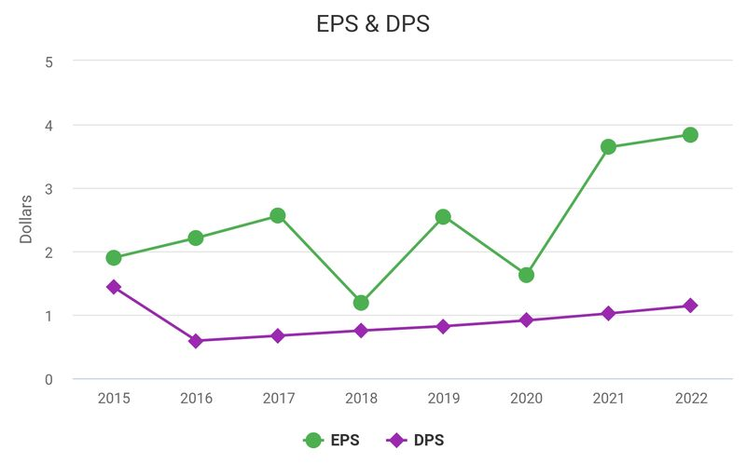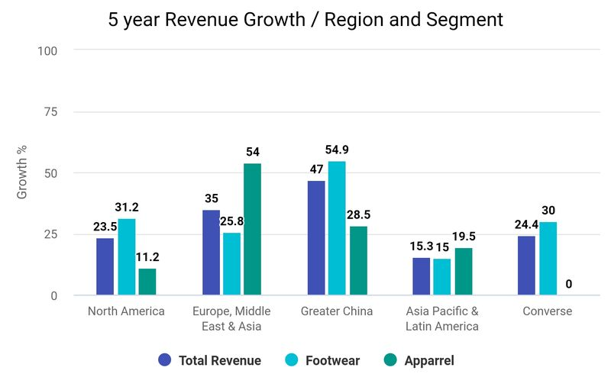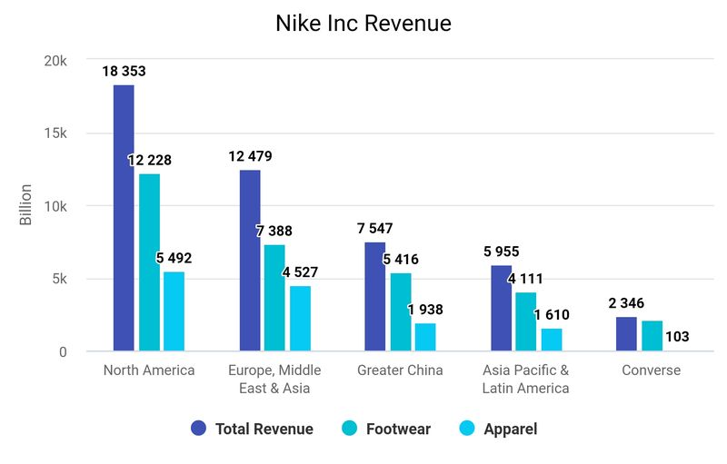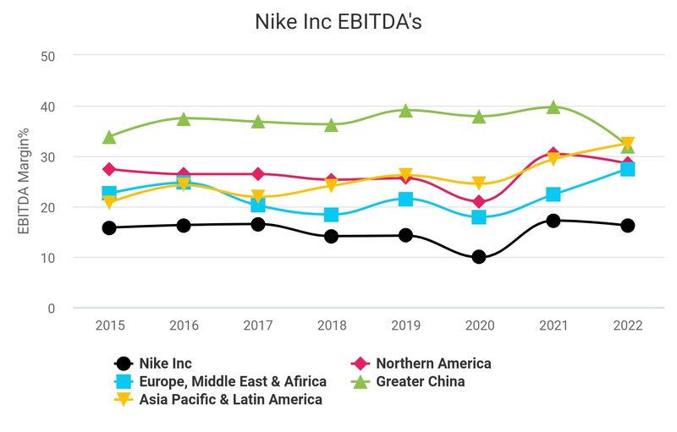

**Point 2: Nike's** total EBITDA has sustained a Margin of between 14% - 17% every year since 2015 excluding the year of the pandemic.Of the core segmental regions, **Greater China** has the stand out performance with an EBITDA ranging between 32% - 39% every year since 2015 with the majority being in the high 30's range. **North America** being Nikes core driver of revenue recorded consistent EBITDA's year on year all between 25% - 30%. **Europe, middle East and Africa** the second largest driver of revenue has ranged between 20% - 27.5%, 27.5% being the latest and highest EBITDA recorded in 2022 **Asia Pacific & Latin America** ranges between 21% - 32.5%, however a clear increasing trend since 2017 is present with 2022 also being the highest EBITDA at 32.5%. **Converse** is also showing improvements with 2022's EBITDA at 29.5%, its highest since 2015. **Global brands and corporate** are showing high percentile negative EBITDA's as through out all years but increasing in a stable, gradual trend in line with overall revenue.Overall margin has been very consistent with evidence to support the coming years improving further due to all regions simultaneously showing similar improvements setting new highs in 2021- 2022.

**Point 3:**

**EPS,** continually rising with sharp increases in 2021. The company's plans to increase its share count in the coming years should continue to effect EPS positively looking forward.

**Capex** was gradually increasing until 2019, where the past few years have seen a significant and impressive decrease, a lower Capex in 2021 and 2022, than in 2015. Potential to rise gradually in coming years but to remain at lower levels is probable, due to consistent Capex performance across all segments implying a genuine all around sustainable improvement throughout the company.  
**FCFF** is currently around 20% 25% of it current debt. Debt has also been growing since 2015 but has not increased further in the past 4 years.  
FCFF is around 5'000 billion, a decrease of 2'000 billion from the prior year. An increase in FCFF and decrease in debt would be desirable.  
Further loans to acquire shares have been taken, uncertainty remains as to the reduction of debt. However improving capex, revenue and EBITDA suggest FCFF may improve also.

**North America** continues to be Nike's largest revenue driver making up around 40% of the company's total revenue. Footwear being the most influential segment making up around 65% and has grown 31% in the past 5 years.  
**Europe, middle east and Africa** is Nike's second biggest source of revenue at around 26%. Overall revenue in these regions has grown 35% in the past 5 years, however apparel has seen the most significant at around 54% and this segment is out performing all other regions in terms of growth.  
**Greater China** is nikes 3rd largest source of revenue and has seen the greatest growth of all regions by around 47% in the past 5 years, most notably footwear, with growth of 55%.

**To summarize the key drivers in the years to come:**  
Footwear in North America.  
Apparrel in Europe and Middle East.  
Greater China as the region for increasing overall growth potential.

Company Name: **Nike Inc** Ticker: **NKE**

Current Share Price: $99.80

Upside: $170 / + 70.34% Downside: $85 / - 14.83%

Upside/Downside to current share price: ((Forecasted Price – Current Price)/Current Price)

**Investment thesis:**

**Nike inc,** A long standing established clothing brand recognized globally demonstrating consistent year on year revenue growth, profits, innovation and performance.Stable continuation of consistency is anticipated with high probability.